A1 – PVC Plates

Thin Plate:
Etching Lines:
First off, we had to etch one horizontal line 4mm off the bottom of the plate.
Secondly, we had to etch three vertical lines on the bottom line, two of them 20mm off each side and the third one 87mm off the left side.
Thirdly, we had to etch one vertical line on each side of the plate, each 17mm off the sides. Afterwards we had to etch two horizontal lines, one on the top and one on the bottom, 20mm off their respective sides.
Fourthly, we had to etch two vertical lines, 55mm and 95mm respectively off the left side of the plate. Then we had to etch two horizontal lines, 35mm and 75mm respectively off the bottom of the plate.

Drilling holes:
Firstly, on the lines that create a rectangle, on each intersection we had to drill holes of 2.5mm.
Secondly, we had to drill three holes on the bottom line, on each intersection we had to drill holes of 3mm and have a countersunk of 5.7mm with a 90-degree incline.
Thirdly, we had to drill a big enough hole, so that we could file it perfectly to the size of the square that we etched.
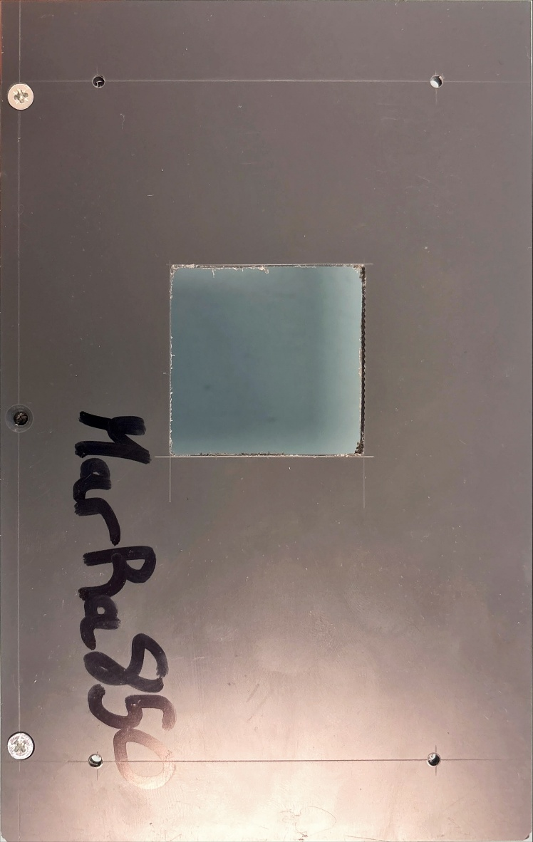

Thick Plate:
Etching Lines:
Firstly, we had to etch four vertical lines, one 5mm, 70mm, 106mm and 155mm off the right side of the plate. Then we had to etch three horizontal lines, one 15mm, 74mm and 85mm off the bottom side of the plate.
Secondly, we had to etch one vertical line, 80mm off the left side of the plate.
Finally, we had to etch one horizontal line on the thin side of the plate where the four holes will be drilled in one line. The line will be 4mm of the bottom part of the plate. Then we had to etch three vertical lines, two being 13mm off the left and right side of the plate and the last one being 80mm off the left side of the plate.

Drilling holes:
Firstly, the line in the top middle of the plate, we drilled a hole of 4mm.
Secondly, all other intersection on the board, we drilled holes of 2.5mm.
Finally, on the thin side of the board, we drilled holes of M3x0.5 6H.
